IOT Arduino Circuit

**DHT sensor circuit**

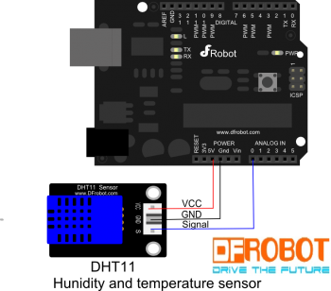

**Need:**

|  |
| --- |
| http://www.hardcopyworld.com/ngine/aduino/wp-content/uploads/sites/3/2013/12/1365485526-516x350.jpg |
| Sensor: DHT- 11 |

**Heat Sensor circuit**

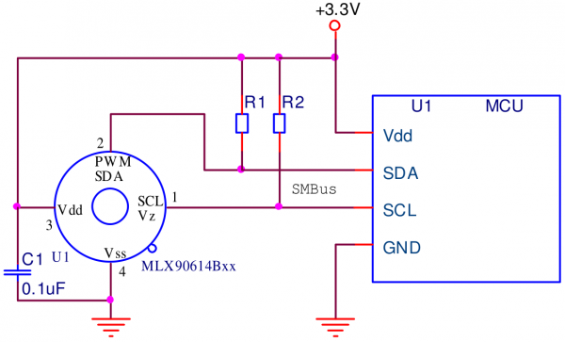

**Need:**

|  |  |
| --- | --- |
| Infrared Thermometer - MLX90614 |  |
| Sensor: MLX90614ESF-AAA-000-SP | 4.7kΩ Resistor x 2 |

**Air-Condition circuit**

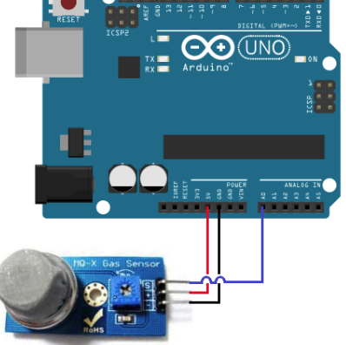

**Need:**

|  |
| --- |
| https://rydepier.files.wordpress.com/2015/07/img_2006.png?w=765&h=651 |
| Sensor: MQ2 Gas Sensor |